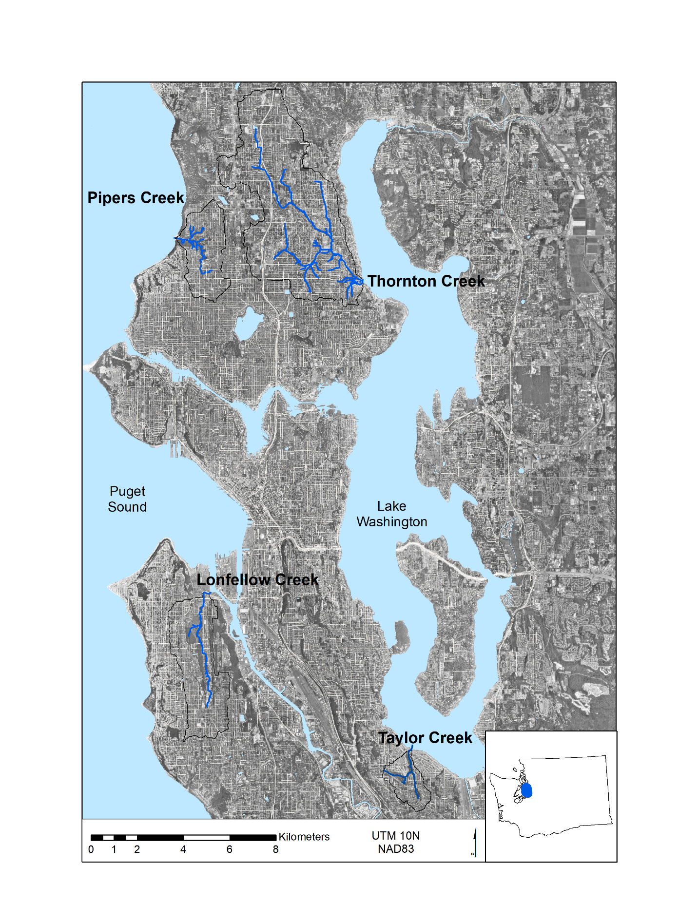

Figure 1. The four watersheds in Seattle, Washington examined in this study.

Figure 2. A single VELMA voxel depicting lateral and vertical flows. The left panel is a standard VELMA setup, and the right panel is the changed voxel structure to represent green roofs.

Layer 2

Layer 3

Layer 4

Green Roof

Impermeable Layer

Boundary

Layer 2

Layer 3

Layer 4

Layer 1

Boundary

Optional Impermeable Layer

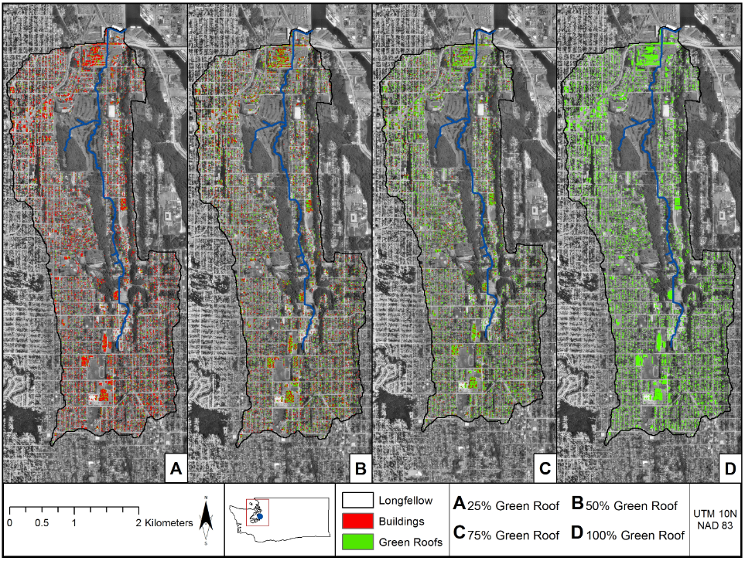

Figure 3. Spatial distribution of green roofs implemented in varying proportions (25%, 50%, 75%, and 100%) of existing buildings within the Longfellow Creek watershed.

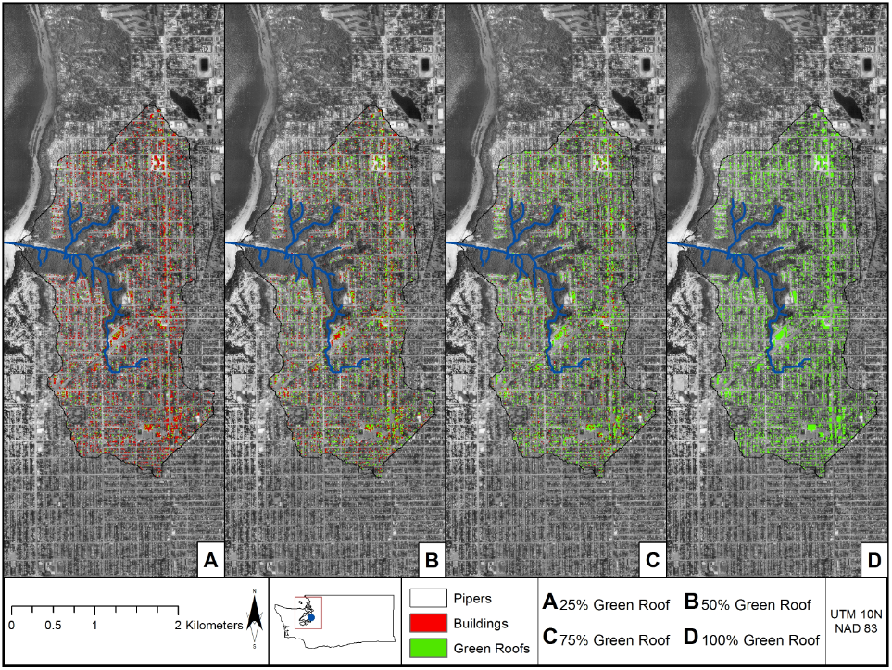

Figure 4. Spatial distribution of green roofs implemented in varying proportions (25%, 50%, 75%, and 100%) of existing buildings within the Pipers Creek watershed.

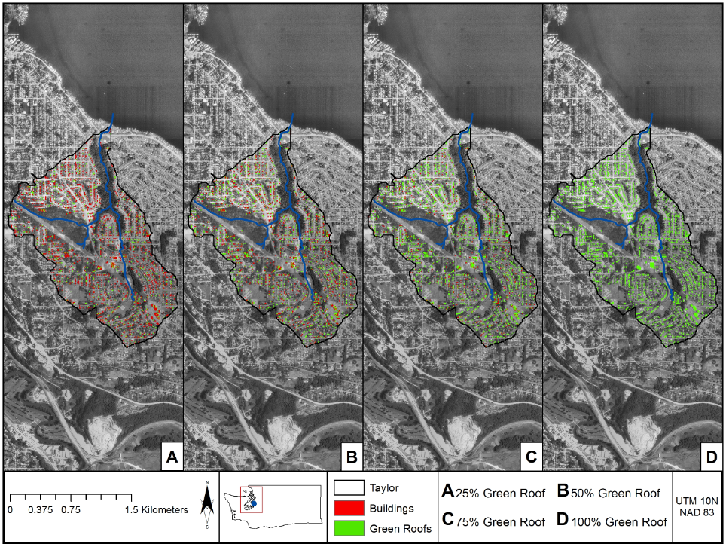

Figure 5. Spatial distribution of green roofs implemented in varying proportions (25%, 50%, 75%, and 100%) of existing buildings within the Taylor Creek watershed.

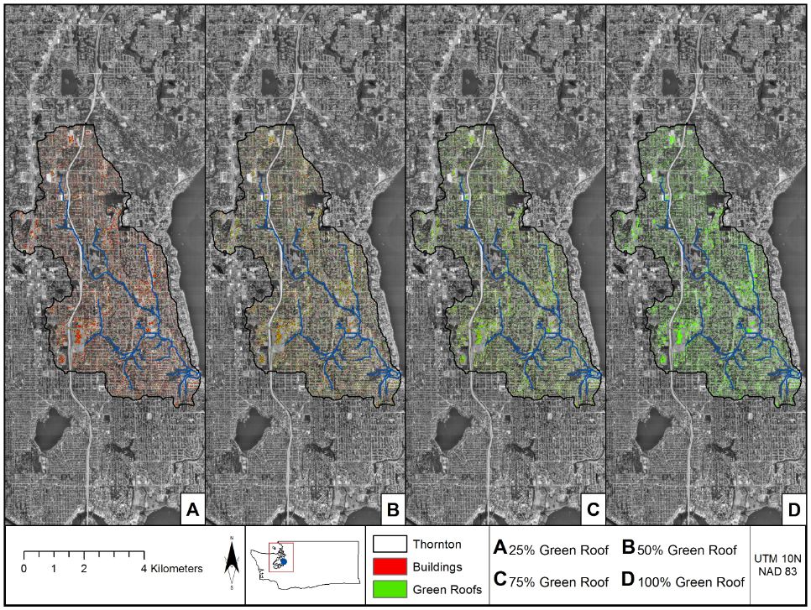

Figure 6. Spatial distribution of green roofs implemented in varying proportions (25%, 50%, 75%, and 100%) of existing buildings within the Thornton Creek watershed.

**THIS FIGURE WILL BE REPLACED WITH NEW RESULTS.**

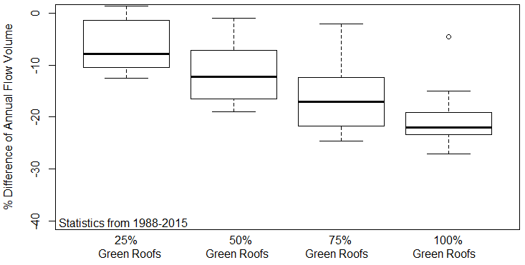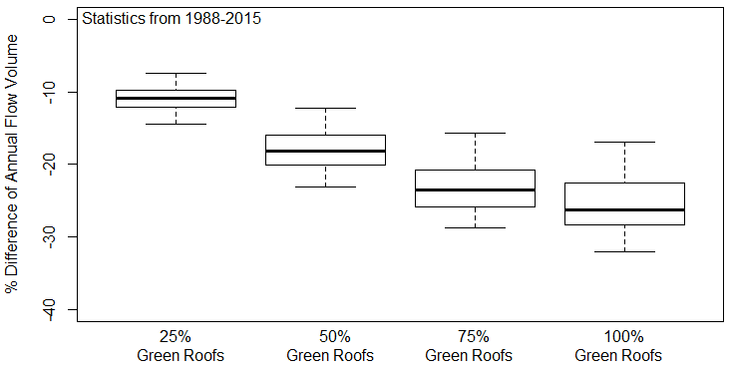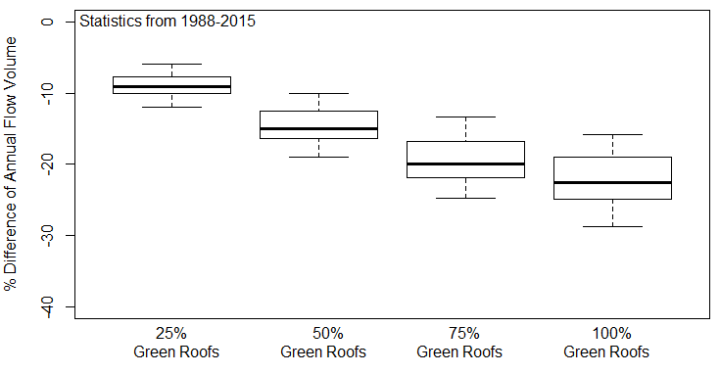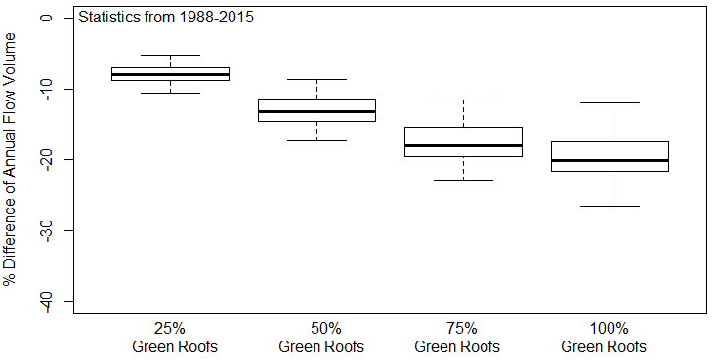

Longfellow

Taylor

Pipers

Thornton

**Figure 7.** Percentage differences between the annual flow volume for the baseline simulations and the four scenarios of green roof implementations (25%, 50%, 75%, 100%) for the intensive green roof simulations. Simulations were run for 29 years (1987-2015), and the first year was a spin-up year and was not included in the results. The boxplots show the annual statistical variations.

**<Insert Figure 8 Here // Extensive Green Roof Reductions. >**

**Figure 8.** Percentage differences between the annual flow volume for the baseline simulations and the four scenarios of green roof implementations (25%, 50%, 75%, 100%) for the extensive green roof simulations. Simulations were run for 29 years (1987-2015), and the first year was a spin-up year and was not included in the results. The boxplots show the annual statistical variations.

<Insert Figure 8> Rainfall versus Discaharge reduction percentages for a particular watershed.

|  |  |  |  |  |
| --- | --- | --- | --- | --- |
| **Table 1.** Within-watershed land use classification percentages. | | | | |
|
|  | **Longfellow** | **Pipers** | **Taylor** | **Thornton** |
| Buildings | 10% | 11% | 10% | 10% |
| Impervious Surfaces (e.g., Roads, Parking Lots, Sidewalks) | 31% | 24% | 24% | 26% |
| Trees | 34% | 46% | 42% | 42% |
| Grass | 25% | 19% | 24% | 22% |
| Watershed Area | 11 km2 | 6.5 km2 | 3 km2 | 31 km2 |

|  |  |  |  |  |  |
| --- | --- | --- | --- | --- | --- |
| **Table 2.** Watershed model input data acquisition and sources. | | | | | |
|
| **Organization** | **Dataset** | **Data type** | **File Format** | **Scale** | **Uncertainty\*** |
| United States Geological Survey (USGS) | National Elevation Dataset | Elevation | Raster | 1/3 arc-second | Z value RMSE = 2.44 m |
| City of Seattle | Urban Streams | Hydrography Dataset | Shapefile | NA | Unknown |
| University of Washington | Land use/land cover | Land Cover/Use | Raster | 1 m | Unknown |
| National Oceanic and Atmospheric Association (NOAA) | Temperature and Precipitation | Daily, Point Location | csv | NA | Unknown |
| ORNL / Daymet | Temperature and Precipitation | Daily, Point Location | csv | NA | Year 2000 Mean Daily Bias: +0.012cm, -0.123 C° |
| United States Department of Agriculture (USDA) | State Soil Geographic data base | Soils | Raster | 10 m | Highly dependent on scale and field methods |

Table 3. Overview of soil characteristics used in the watershed model simulations.

|  |  |  |  |
| --- | --- | --- | --- |
| **Soil Property** | **General** | **Extensive Green Roofs (1st layer)** | **Intensive Green Roofs (1st layer)** |
| Porosity (v/v) | 0.453 | 0.70 | 0.70 |
| Field Capacity (v/v) | 0.207 | 0.60 | 0.65 |
| Wilt Point (v/v) | 0.095 | 0.12 | 0.12 |
| Hydraulic Conductivity (mm/day) | 770 | 87,000 | 10,000 |
| Bulk Density (g/cm3) | 1.52 | 0.50 | 0.75 |
| Depth (mm) | 500 | 100 | 500 |
| pH | 4.5 | 7 | 7 |

Table 4. An overview of the discharge calibration process for the Taylor Creek watershed.

|  |  |  |  |
| --- | --- | --- | --- |
| **Parameter** | **Uncalibrated Ranges** | **Calibrated Ranges  (NSE > 0.6)** | **Final Calibrated Value** |
| be | 5 - 15 | 5 - 15 | 7 |
| Petparam 1 (Conifer) | 0.25 - 1.0 | 0.27 - 0.92 | 0.99 |
| Petparam 1 (Grass) | 0.25 - 1.0 | 0.25 - 0.99 | 0.96 |
| ksLat | 0.00001 - 0.001 | 0.00001 - 0.0001 | 0.00009 |
| ksVert | 0.0005 - 0.005 | 0.001 - 0.005 | 0.002 |
| Surface Saturated Hydraulic Conductivity (mm/day) | 500 - 25000 | 522 - 3023 | 800 |

**THIS IS JUST FOR REFERENCE FOR ME.**

Table 5. List of calibration parameters used to calibrate the four watershed models.

|  |  |  |  |  |
| --- | --- | --- | --- | --- |
| Parameter | Description | Layer | Value | Unit |
| *z* | Soil layer thickness | 1, 2, 3, 4 | 500, 500, 12000, 12000 | mm |
| *K*s,l | Saturated lateral hydraulic conductivity | 1, 2, 3, 4 | 130, 100, 80, 30 | mm day-1 |
| 50, 30, 15, 10 |
| *K*s.v | Saturated vertical hydraulic conductivity | 1, 2, 3, 4 | 14, 14, 10, 10 | mm day-1 |
| 7, 7, 5, 5 |
| *n* | Porosity fraction | All | 0.501 | - |
| 0.475 | - |
| *P*b | Bulk density | All | 1.42 | g cm-3 |
| 1.21 |
| θwp | Wilting point | All | 0.133 | - |
| 0.272 | - |
| θfc | Field capacity | All | 0.33 | - |
| 0.396 | - |